Ferrarichat.com July 29, 2026

To Whom It May Concern:

I am Investigator Jackson, a fraud investigator with the Durham Police Department. I have been investigating Christopher Sawyerr for a while now. I was shown your web site along with others showing the fraudulent activity by Mr. Sawyerr.

If your readers have legitimate complaints, have evidence to prove their case, and is willing to prosecute then I recommend they file a complaint with the Durham Police department. If they file a complaint, I will investigate the case and charge Mr. Sawyerr if it deems necessary. Mr. Sawyerr has nine warrants already for doing fraudulent activity over the Internet.

If your readers would like to file a complaint they can call 919-560-4174 and inform the call taker that they want to file a police report over the telephone. The complainants can also e-mail their complaints to me at aljackson@ci.durham.nc.us. The complainants must have the e-mail correspondence to and from Mr. Sawyerr, and proof that they paid Mr. Sawyerr.

If anyone would like to contact me feel free to at 919-560-4440 ext 232 or at aljackson@ci.durham.nc.us. Thank you in advance.

Sincerely,

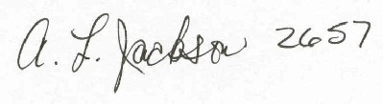

Inv. Jackson

